Question Revision

1.

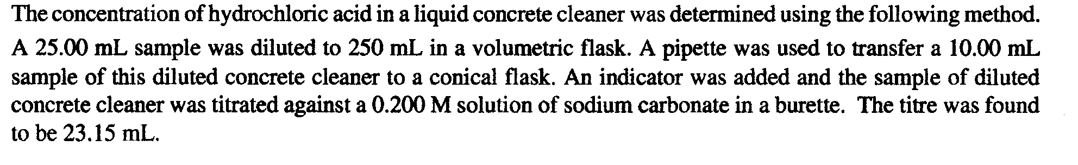
2.
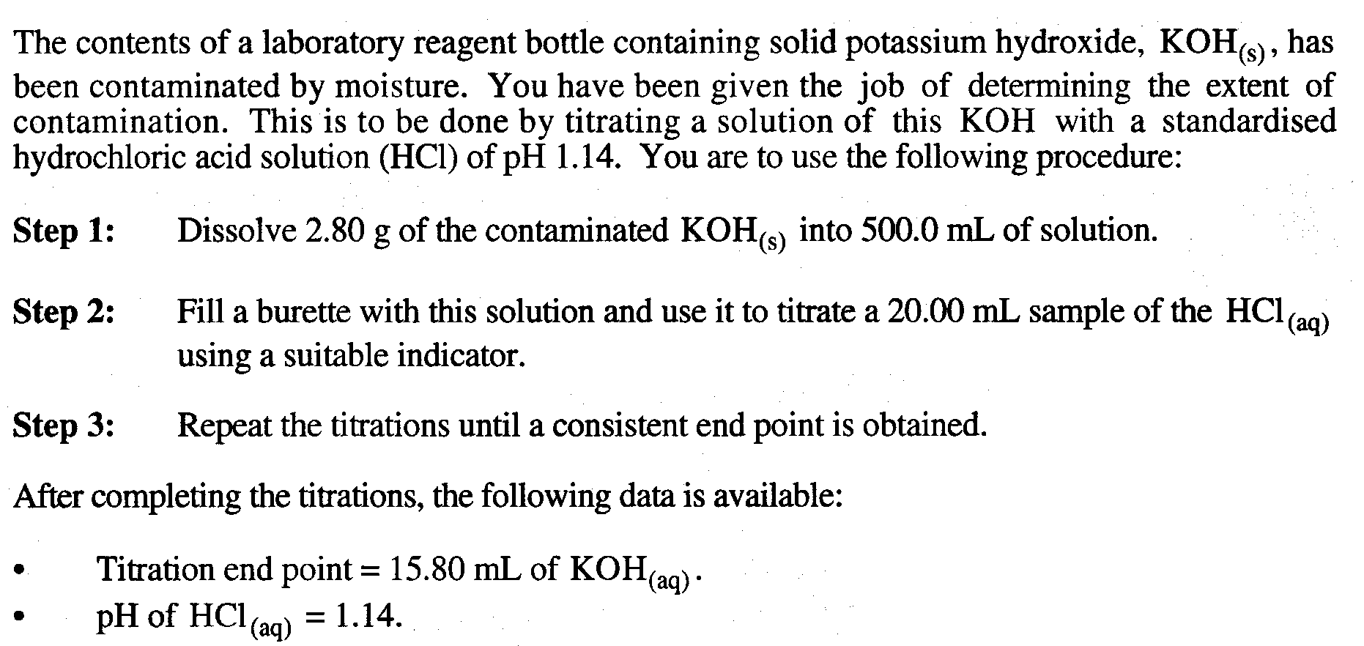

3.
A supermarket brand of vinegar is to be analysed for its ethanoic acid content by a titration technique. This requires the preparation of a Na₂CO₃(aq) primary standard. The primary standard is made by dissolving 1.416 g of anhydrous Na₂CO₃(s) in some distilled water and making the solution up to exactly 500.0 mL using a volumetric flask.

A 50.00 mL sample of the vinegar is diluted to exactly 1.000 L in another volumetric flask. Four 25.00 mL samples of this solution are placed into separate conical flasks and titrated with the Na₂CO₃(aq) primary standard. On average 23.55 mL of the Na₂CO₃ solution was required for equivalence.

Na₂CO₃(aq) + 2CH₃COOH(aq) -------> 2NaCH₃COO(aq) + H₂O(l) + CO₂(g)

Determine the percentage by mass of ethanoic acid in the undiluted vinegar if this vinegar has a density of 1.060 g mL⁻¹.

1
(a) Calculate the concentration of HCl in the original sample of concrete cleaner.

Na₂CO₃
c = 0.200 mol L⁻¹
V = 0.02315 L
A
C
D
250 mL

Cleanser with HCl

25.00 mL
10.00 mL
B

n(Na₂CO₃)_{A} = cV = 0.200 x 0.02315 = 0.00463
n(HCl)_{B} = 2 x n(Na₂CO₃)_{A} = 2 x 0.00463 = 0.00926 mol
c(HCl)_{C} = (n(HCl)_{B})/0.0100 = 0.00926/0.01 = 0.926 M
n(HCl)_{C} = cV = 0.926 x 0.250 = 0.2315 mol
c(HCl)_{D} = n/V = 0.2315/0.025 = 9.26 M

2.

Calculate the percentage by mass of moisture in the contaminated KOH(s)

500 mL
B
C
D
2.80 g Impure KOH
KOH
V = 0.01580 L

A

HCl
pH = 1.14
V = 20.0 mL

n(HCl)_{A} = cV = 10^{-1.14} x 0.020 = 1.45 x 10⁻³ mol
n(KOH)_{B} = n(HCl)_{A} = 1.45 x 10⁻³ mol
c(KOH)_{B} = n/V = (1.45 x 10⁻³)/0.01580 = 9.17 x 10⁻² M
c(KOH)_{C} = 9.17 x 10⁻² M
n(KOH)_{C} = c x V = (9.17 x 10⁻²) x 0.500 = 0.0459
m(NaOH)_{D} = n x M = 0.0459 x 56.1056 = 2.58 g
%(KOH) in impure sample = (2.58/2.80) x 100 = 92.0%

3.
A supermarket brand of vinegar is to be analysed for its ethanoic acid content by a titration technique. This requires the preparation of a Na₂CO₃(aq) primary standard. The primary standard is made by dissolving 1.416 g of anhydrous Na₂CO₃(s) in some distilled water and making the solution up to exactly 500.0 mL using a volumetric flask.

A 50.00 mL sample of the vinegar is diluted to exactly 1.000 L in another volumetric flask. Four 25.00 mL samples of this solution are placed into separate conical flasks and titrated with the Na₂CO₃(aq) primary standard. On average 23.55 mL of the Na₂CO₃ solution was required for equivalence.

Na₂CO₃(aq) + 2CH₃COOH(aq) -------> 2NaCH₃COO(aq) + H₂O(l) + CO₂(g)

Determine the percentage by mass of ethanoic acid in the undiluted vinegar if this vinegar has a density of 1.060 g mL⁻¹.
[10 marks]

Vinegar
50.00 mL
1 L
25.00 mL
Na₂CO₃
V = 0.02355 L
D
C
D
1.416 g Na₂CO₃
E
B
A
500 mL
C

F

n(Na₂CO₃)_{A} = m/M = 1.416/105.9884 = 1.336 x 10⁻² mol
c(Na₂CO₃)_{B} = n/V = (1.336 x 10⁻²)/0.500 = 2.67 x 10⁻² M
n(Na₂CO₃)_{added from Burette C} = cV = (2.67 x 10⁻²) x 0.02355 = 6.29x 10⁻⁴ mol
n(CH₃COOH)_{D} = 2 x n(Na₂CO₃)_{added from Burette C} = 2 x (6.29x 10⁻⁴) = 1.26 x 10⁻³ mol
c(CH₃COOH)_{E} = n/V = (1.26 x 10⁻³)/0.02500 = 5.03 x 10⁻² M
n(CH₃COOH)_{E} = cV = (5.03 x 10⁻²) x 1 = 5.03 x 10⁻² mol
c(CH₃COOH)_{E} = n/V = (5.03 x 10⁻²)/0.0500 = 1.01 M

density of vinegar = 1060 g / L
therefore, mass of 1 L solution = 1060 g
number of moles CH₃COOH in 1 L = 1.01
therefore, mass of CH₃COOH in 1 L = n x M = 1.01 x 60.0519 = 60.5g
%(CH₃COOH) = [(mass of CH3COOH)/(mass of solution)] x 100
= (60.5/1060) x 100 = 5.7%

